Deep Skilling Week 8 Assignment

- Familiar with Git commands like git init, git status, git add, git commit, git
push, and git pull.

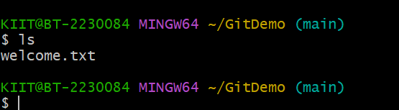

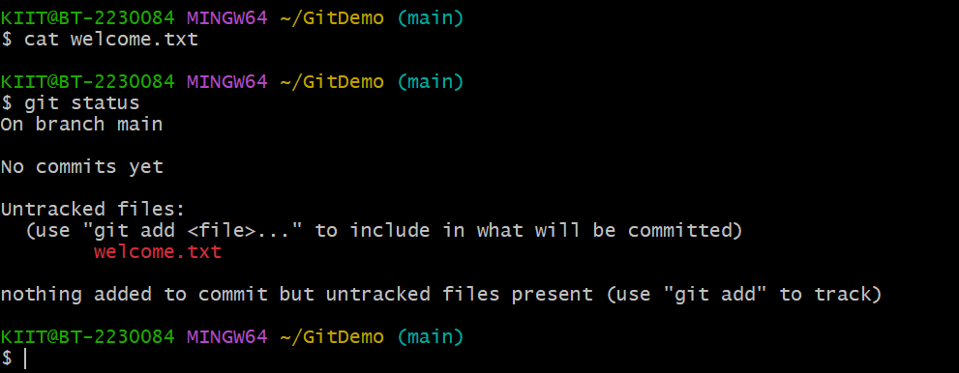

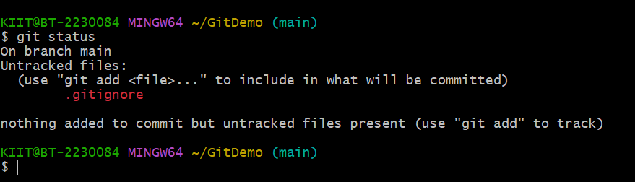
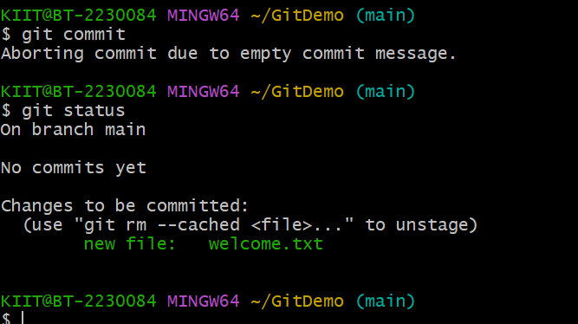

- Implement git ignore command to ignore unwanted files and folders

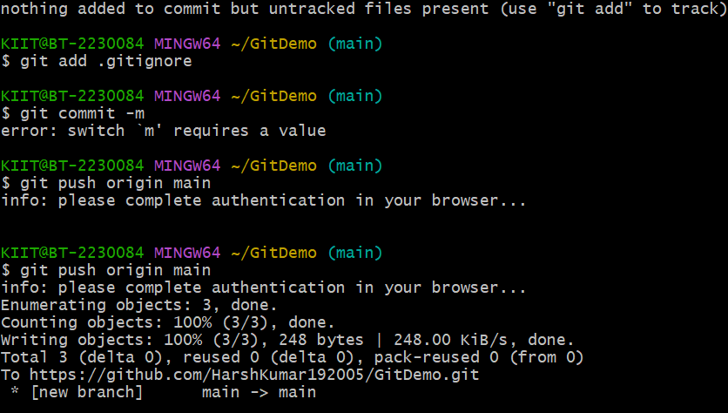

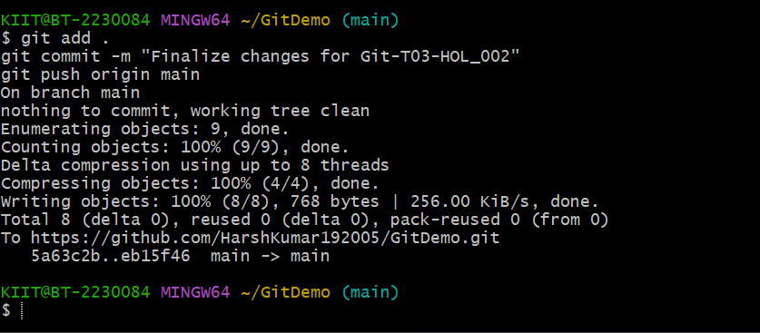

- Construct a branch, do some changes in the branch, and merge it with
master (or trunk)

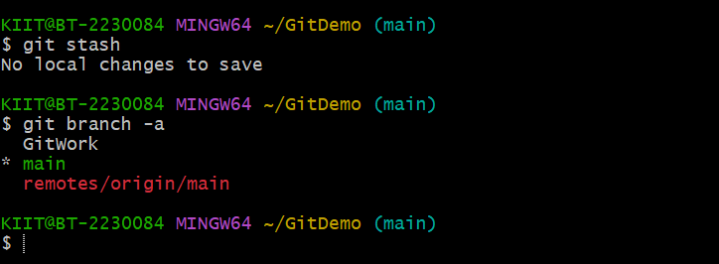

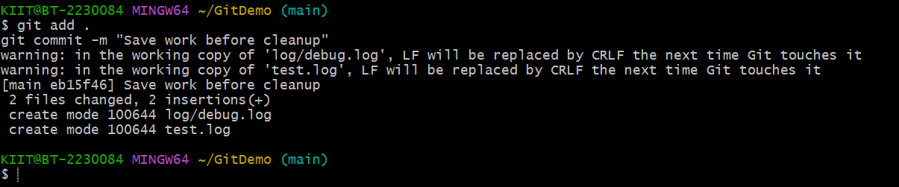

- Implement conflict resolution when multiple users are updating the trunk (or
master) in such a way that it results into a conflict with the branch’s modification.

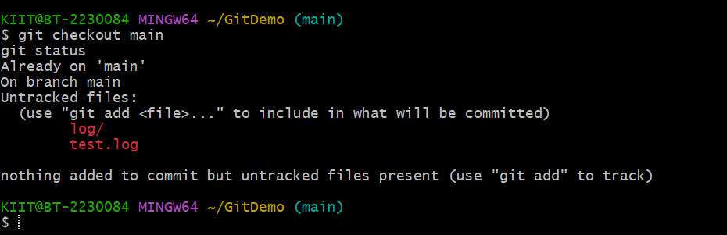

- Explain how to clean up and push back to remote Git

